AI-Enhanced Smart Gate Access Control System with
Integrated Dress Code Recognition

A Capstone Project
presented to the Faculty of the
College of Information and Communications Technology
Iloilo State University of Fisheries Science and Technology
Dingle Campus
Dingle, Iloilo

In partial fulfilment
of the requirements for the Degree
Bachelor of Science in Information Technology

by
Lou Vincent Baroro
Shamy Descalsota
Katherine Olido
Joysie Ann Notada
Catherine Lanado

April 2026

CHAPTER 1
INTRODUCTION
1.1 Background of the Study
The rapid advancement of Artificial Intelligence (AI) and Internet of Things (IoT) technologies has opened new frontiers in campus security and administrative automation. According to Sikos (2019), the integration of intelligent systems in institutional environments significantly improves the efficiency and accuracy of access management, reducing the reliance on manual processes that are inherently prone to human error. Educational institutions around the world are increasingly adopting AI-powered systems to automate routine tasks such as identity verification, attendance recording, and policy enforcement.
In the Philippines, state universities and colleges face persistent challenges in maintaining orderly and secure campus environments. Campus gate security traditionally depends on security personnel who manually verify student identification and dress code compliance. This approach, while conventional, is time-consuming and inconsistent, particularly during peak entry hours when hundreds of students arrive simultaneously. As noted by Dela Cruz and Santos (2022), manual security processes in Philippine academic institutions are susceptible to lapses in vigilance, resulting in inconsistent enforcement of institutional policies.
Recent security incidents in Iloilo City, including reported false bomb threats in nearby educational institutions, have underscored the urgent need for proactive and technology-driven approaches to campus security. Manalansan (2023) observed that Philippine campuses are increasingly vulnerable to security breaches arising from inadequate access control mechanisms, and that automated identification systems represent a cost-effective and scalable solution to these concerns.
The integration of biometric authentication particularly face recognition into campus gate systems has been demonstrated to significantly reduce unauthorized entry and improve attendance data accuracy. Research on automated dress code monitoring systems has shown that computer vision techniques, when applied at entry points, can objectively and consistently enforce institutional uniform policies without depending on individual human judgment (Mukherjee et al., 2021).
ISUFST Dingle Campus, like many Philippine state universities, currently relies on manual inspection at its main gate. Security personnel are tasked with simultaneously verifying student identity and checking uniform compliance — a dual responsibility that frequently leads to incomplete enforcement, particularly when personnel are fatigued or distracted. This study proposes the development of a prototype Smart Gate Access Control System for the College of Information and Communication Technology (CICT) that integrates AI-based face recognition and YOLO11 Nano object detection for dress code enforcement into a unified, offline-capable system designed exclusively for enrolled CICT students. A momentary keyswitch operated by the security guard serves as the physical fallback mechanism for cases where the automated system cannot complete recognition. By limiting the initial deployment to the CICT department entrance, the study aims to demonstrate technical feasibility before proposing campus-wide implementation.

1.2 Objectives of the Study
General Objective
To design, develop, and evaluate an AI‑Enhanced Smart Gate Access Control System with Integrated Dress Code Recognition for CICT at ISUFST Dingle Campus.
Specific Objectives
The study aims to:
- Develop a face recognition module using dlib that accurately identifies enrolled CICT students and completes recognition within a practical processing time (target ≤ 2 seconds per student).
- Implement an automated uniform top detection module using YOLO11 Nano to verify that a student is wearing the prescribed CICT uniform before access is granted.
- Build an offline‑first system with a local SQLite database and a Supabase cloud dashboard to log entry timestamps and synchronise attendance data when internet is available.
- Evaluate the system using ISO 25010 standards in terms of functional suitability, reliability, usability, performance efficiency, and security.

Conceptual Framework
This study was conducted to develop an AI-enhanced Smart Gate Access Control System with Integrated Dress Code Recognition to automate student identity verification and uniform policy enforcement at the ISUFST Dingle Campus.

Input.The input stage encompasses three categories of data. The first is Student Information, which includes student IDs and facial images registered into a local SQLite database during setup. The second is the Live Camera Feed, providing the real-time video stream for both face recognition and YOLO11 uniform detection. The third is the Keyswitch Signal, which allows a security guard to physically trigger a fallback override if the camera is obstructed or recognition fails.

Process. This is the "brain" of the system where core decision logic is executed. The Face Recognition (dlib) module identifies the student by comparing a 128-dimensional embedding from the camera frame against the database. Simultaneously, the Uniform Detection (YOLO11) module determines if the student is wearing the prescribed CICT uniform top. The system also manages Manual Override Logic from the keyswitch and maintains the Entry Log by recording all outcomes automated grants, denials, or manual overrides into a local file for later cloud synchronization.

Output. The system produces three types of results. The first is the Access Result Display, shown on the kiosk screen as a "Grant" or "Deny" message with specific reasons and audio feedback. The second is Gate Actuation, where a servo motor physically opens the barrier for a configured duration. The third is the Generated Attendance Reports, consisting of timestamped logs stored locally and made accessible to administrators through a cloud dashboard for monitoring attendance patterns.
- System Evaluation. To ensure the system is reliable and functional, it is evaluated against the ISO 25010 Standards, measuring quality factors such as performance efficiency, security, and usability.

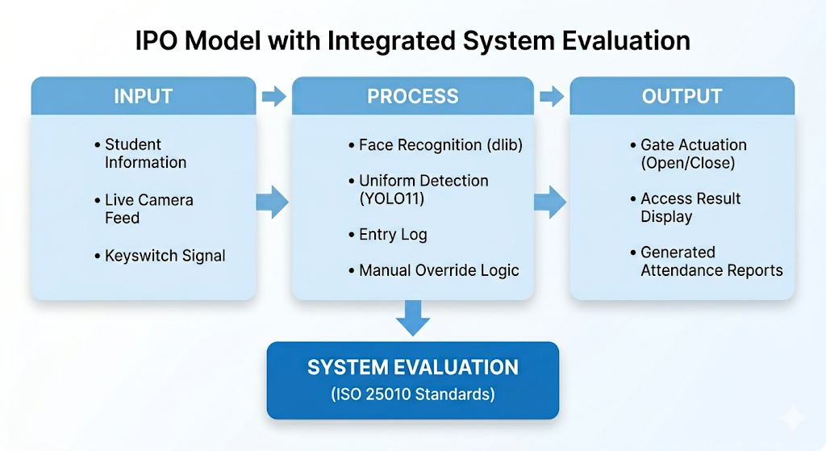
Figure 1. Input-Process-Output (IPO) Conceptual Framework of the Smart Gate System
1.4 Significance of the Study
This study is significant to multiple stakeholders within the ISUFST Dingle Campus community as well as to the broader field of educational technology in the Philippines.
ISUFST Dingle Campus — The prototype system will provide the campus administration with a concrete, low-cost proof-of-concept for AI-powered access control, demonstrating that automated student gate systems are technically and financially feasible within the resource constraints of a Philippine state university. The system positions ISUFST Dingle Campus as a model institution for technology-driven governance among similar academic institutions in Western Visayas.
Security Personnel — The security guard assigned to the CICT campus gate will benefit from a significant reduction in manual inspection workload. Rather than inspecting every entering student by eye, the guard will be able to monitor the system's automated decisions and handle exception cases. The keyswitch fallback mechanism gives the guard direct physical control of the gate at all times, ensuring that automation does not remove human oversight from the security process.
Students — Enrolled CICT students will experience a faster and more objective entry process. Instead of waiting in queues for manual inspection, students will pass through the gate in a streamlined, automated flow. Students who are out of uniform will receive immediate, specific feedback from the system, reducing ambiguity and giving them a fair opportunity to address the non-compliance before proceeding.
Future Researchers — The integrated architecture combining edge AI, IoT hardware, offline-first design, and cloud administration demonstrated in this prototype provides a documented and replicable model for building similar systems in other institutional contexts. The ISO 25010 evaluation framework and methodology used in this study contribute to the growing body of applied AI research in Philippine academic literature and offer a testable standard for future capstone projects in the same domain.

1.5 Scope and Limitations
This study covers the design, development, and evaluation of a prototype smart gate access control system deployed at the entrance of the College of Information and Communication Technology (CICT) building at ISUFST Dingle Campus in Dingle, Iloilo during the academic year 2025–2026 (Where). The system will operate continuously during campus gate hours, maintaining full offline functionality throughout gate hours regardless of internet availability (When). The system is designed exclusively for enrolled CICT students, with a maximum enrollment capacity of fifty (50) individuals whose facial images and student information will be registered in the local database on a Raspberry Pi 4 or 5 edge device (Who). In terms of what the system will do, it will perform face recognition for student identity verification, detect the presence or absence of the CICT uniform top using YOLO11 Nano, provide a guard-operated momentary keyswitch as a fallback override mechanism, actuate a servo-based model gate barrier, log all entry events with timestamps in a local SQLite database, and synchronize entry records to a Supabase cloud dashboard accessible by the system administrator (What).
The prototype assumes a security guard is present at the gate to supervise for spoofing attempts and to operate the keyswitch fallback when automated recognition fails. The system performs best in well-lit environments; recognition accuracy may degrade under very dim lighting or direct glare. The study acknowledges the following limitations: the gate actuator is a servo motor operating a small-scale model barrier, not an industrial-grade turnstile or boom gate; the YOLO11 Nano model is trained exclusively on CICT department uniform tops and will not evaluate other departments' uniforms; the system does not track exit events or detect when a student departs early; and anti-tailgating measures to prevent multiple individuals from passing through on a single recognition event are not implemented in this prototype version.
1.6 Definition of Terms
The following terms are defined conceptually, based on published literature, and operationally, as they are applied within this study. Operational definitions use plain language to make the system's behavior clear to non-technical readers.
Access Control System. Conceptually, an access control system is a security mechanism that regulates who is allowed to enter or exit a specific physical location through the use of credentials such as identification or biometric data (Vacca, 2013). Operationally, this is the automated gate installed at the CICT entrance that decides whether to open for each student based on whether their face is recognized and their uniform top is detected.
Biometric Authentication. Conceptually, biometric authentication is the process of verifying a person's identity by measuring unique physical characteristics, such as facial features, that are inherent to the individual (Jain, Ross, & Pankanti, 2006). Operationally, this is how the gate 'recognizes a face' — it compares the student's live face to stored face data to confirm the person is an enrolled CICT student.
Dress Code Enforcement. Conceptually, dress code enforcement is the institutional process of monitoring whether individuals comply with established appearance standards (DeMitchell & Fossey, 2015). Operationally, this is the system's ability to check whether a student is wearing the CICT uniform top by looking at what they are wearing through the camera.
Edge Computing. Conceptually, edge computing is a paradigm where data processing occurs near the physical source of the data rather than in a distant cloud server, reducing latency and network dependency (Shi et al., 2016). Operationally, this means all the smart decision-making happens on the small Raspberry Pi computer at the gate itself — no internet is needed to operate the gate.
Face Recognition. Conceptually, face recognition is a biometric technology that identifies a person by analyzing patterns in their facial features from a digital image or video (Zhao et al., 2003). Operationally, this is the part of the system that looks at a student's face through the camera and determines who they are by comparing their face to the list of enrolled students stored in the device.
Internet of Things (IoT). Conceptually, the Internet of Things refers to a network of physical objects embedded with sensors and connectivity that enables them to exchange data (Ashton, 2009). Operationally, IoT refers to the network of hardware pieces — the Raspberry Pi, camera, servo motor, and keyswitch — that work together as the physical gate system.
Keyswitch (Guard Override). Conceptually, a keyswitch is a momentary electrical switch activated by inserting and turning a physical key, used as a secure manual control input in automated systems (Kuphaldt, 2006). The spring-returned design means it returns to the off position automatically when the key is released. Operationally, this is the physical key that only the security guard carries. When the guard turns and holds the key for one to two seconds, the gate opens once and the event is recorded as a 'manual override.' This is used when the camera cannot read the student's face or when the system needs a quick human override.
Object Detection. Conceptually, object detection is a computer vision technique that identifies and locates specific objects within an image using bounding boxes and class labels (Ren et al., 2015). Operationally, this is the system's ability to find and draw a box around the student's uniform top in the camera image to check whether they are wearing the correct top.
Offline-First Architecture. Conceptually, an offline-first architecture is a software design approach where an application functions fully without internet connectivity and synchronizes with remote servers only when available (W3C, 2013). Operationally, this means the gate works completely on its own even if the Wi-Fi or internet goes down like a filing system that saves everything locally and only sends it to the cloud when the connection comes back.
Smart Gate. Conceptually, a smart gate is an automated access control barrier that integrates sensors, computing, and communication to control entry (Alharbi et al., 2022). Operationally, the smart gate in this study is the complete prototype system at the CICT entrance the camera, the computer, the keyswitch, and the gate barrier that works together to decide who can enter and records every entry.
SQLite. Conceptually, SQLite is a self-contained, serverless, embedded relational database engine widely used in resource-constrained applications and local data storage (Hipp, 2020). Operationally, SQLite is like a digital filing cabinet that lives inside the Raspberry Pi. It keeps all the student face data and entry records stored locally on the device, even when there is no internet connection.
Supabase. Conceptually, Supabase is an open-source backend-as-a-service platform that provides a PostgreSQL database, authentication, and real-time APIs (Supabase Inc., 2023). Operationally, Supabase is the online storage space where the gate sends its entry records when Wi-Fi is available, so the system administrator can view logs and export attendance data from any device with a browser.
YOLO11 (You Only Look Once, version 11). Conceptually, YOLO is a family of real-time single-pass object detection models that generate bounding box predictions and class probabilities in one forward pass of a neural network (Redmon et al., 2016; Ultralytics, 2024). Operationally, YOLO11 Nano is the smallest and fastest version of this model. It is used in the gate system to look at the student's full body in the camera frame and quickly decide whether they are wearing the CICT uniform top. It runs directly on the Raspberry Pi without needing the internet.

CHAPTER 2
REVIEW OF RELATED LITERATURE AND STUDIES
2.1 Automated Campus Gate and Access Control Systems
Numerous studies have explored the integration of automated gate systems in educational environments. Alharbi, Alghofaili, and Alotaibi (2022) designed a facial recognition-based access control system for a Saudi Arabian university campus. The system was deployed at building entrances and demonstrated high accuracy in identifying students while significantly reducing entry wait times compared to manual security checks. The study highlighted the importance of edge processing to maintain system speed and reliability — a principle directly adopted in the current study.
Rahman, Islam, and Hossain (2023) implemented a smart attendance and access control system for a Bangladeshi university using biometric technology. Their system successfully reduced administrative overhead for attendance tracking and provided a secure entry mechanism. The researchers noted that combining different verification layers provided a more robust solution than relying on a single method, directly supporting the present study's dual-verification design of face recognition combined with uniform detection.
A study by Handayani, Suyanto, and Nugroho (2022) at a vocational high school in Indonesia implemented an automated gate monitoring system using facial recognition and a Raspberry Pi 4 as the edge processor. The study found that the Raspberry Pi 4 was capable of running the face recognition pipeline within acceptable response times (under 2 seconds per identification) when embeddings were cached locally, validating the hardware selection in the present study.
2.2 Face Recognition in Student Attendance Systems
The use of face recognition in student attendance and access systems has been extensively studied. Oloniyo, Samuel, and Fredrick (2025) presented a multimodal student attendance system that integrated facial recognition with other identification methods. Their experimental results demonstrated improved identification accuracy and real-time response with a False Rejection Rate (FRR) of approximately 2.3% across a test population of 120 students, validating the decision to use face recognition as the primary identification method in the present study.
Fagbola, Thakur, and Adigun (2019) conducted a comparative evaluation of biometric systems for student attendance across four Nigerian universities. Their findings confirmed that face recognition systems showed higher error rates in uncontrolled lighting environments, directly informing the present study's decision to include a guard-operated keyswitch as a fallback mechanism for low-visibility scenarios.
Chowdhury, Rahman, and Islam (2021) implemented a Raspberry Pi-based face recognition attendance system for a Bangladeshi university department. They evaluated the effect of image preprocessing — including histogram equalization and face alignment — on recognition accuracy under varying fluorescent lighting conditions. Their study found that preprocessing significantly improved accuracy in suboptimal lighting, demonstrating the importance of the preprocessing pipeline implemented in the proposed system.
King (2017) demonstrated that the dlib face recognition library, which uses a deep metric learning approach, achieves a 99.38% accuracy rate on the Labeled Faces in the Wild (LFW) benchmark dataset. This benchmark directly justifies the selection of dlib as the face recognition library in the proposed system and establishes the accuracy target for Specific Objective 1.
2.3 Computer Vision for Uniform and Dress Code Monitoring
Automated uniform detection using computer vision is an emerging research area with direct relevance to this study. Hoang and Anh (2024) developed a lightweight Convolutional Neural Network (CNN) model for student uniform verification from camera images, achieving 91% classification accuracy with a model size of only 1.58 MB. Their study demonstrated that compact deep learning models are capable of reliably distinguishing students wearing the prescribed school uniform from those who are non-compliant, even under variation in camera angle and distance.
Masombuka, Nyandeni, and Lall (2023) conducted research on automated occupational uniform recognition for video surveillance applications using instance segmentation. Their approach achieved reliable uniform identification across outdoor lighting conditions with significant illumination variation. This finding supports the approach of training a custom YOLO11 Nano model on CICT-specific uniform top images under real campus lighting conditions.
Mukherjee, Bhatt, and Dhavale (2021) developed a two-module machine learning pipeline for school uniform identification using a VGG16-based architecture. The pipeline achieved high accuracy on a held-out test set containing uniforms from schools not present during training, demonstrating strong generalization. This finding supports the feasibility of the custom YOLO11 Nano model approach in the present study.
Ultralytics (2024) released YOLO11 Nano, the smallest variant of the YOLO11 model family, optimized for deployment on edge devices with limited computational resources. The model supports export to NCNN format, which is specifically optimized for ARM-based processors such as the Raspberry Pi. This makes YOLO11 Nano a practical and justified choice for real-time uniform top detection in the prototype.
2.4 IoT and Edge Computing in Campus Security
The deployment of IoT hardware in campus security has received increasing scholarly attention. Kumari, Tanwar, Tyagi, and Kumar (2022) conducted a comprehensive review of IoT-enabled smart campus systems, identifying offline-first data architectures as a critical reliability requirement for systems deployed in environments where network connectivity cannot be guaranteed. Their review found that systems with local edge processing and asynchronous cloud synchronization had significantly higher operational uptime compared to cloud-dependent systems a finding that directly motivated the offline-first architecture in the present prototype.
Suh and Lee (2022) developed an edge computing-based smart campus system for real-time monitoring and access control. Their system demonstrated that deploying AI inference at the edge not only reduced latency but also improved privacy by keeping biometric data locally on the device rather than transmitting it to remote servers. This reinforces the present study's decision to store all face embeddings and entry logs on the Raspberry Pi.
2.5 Keyswitch and Physical Override Mechanisms in Automated Systems
Physical override mechanisms are a recognized best practice in automated access control engineering. Kuphaldt (2006) defines momentary keyswitches as spring-returned switches activated by a physical key, commonly used in industrial control systems to provide authorized operators with direct manual control of automated equipment. The lockable design ensures that only the key-holder in this case, the security guard can trigger the override, maintaining accountability while providing a reliable fallback for system exceptions.
Vacca (2013) notes that all automated access control systems deployed in institutional environments should incorporate a manual override mechanism to address technology failure scenarios and maintain security continuity. The inclusion of a keyswitch in the present prototype directly responds to this requirement, ensuring that the guard retains physical control of the gate at all times and that the system's automation does not introduce a single point of failure.
2.6 ISO 25010 Software Quality Evaluation
ISO/IEC 25010 (ISO, 2011) defines a software product quality model comprising eight quality characteristics: functional suitability, performance efficiency, compatibility, usability, reliability, security, maintainability, and portability. This standard has been widely adopted in academic capstone research as a structured framework for evaluating whether a developed prototype meets its intended quality requirements. The use of ISO 25010 in this study ensures that the system evaluation in Specific Objective 4 is grounded in an internationally recognized standard rather than ad hoc criteria, strengthening the rigor and credibility of the evaluation findings.
2.7 Matrix of Related Literature
Table 1 summarizes the twelve studies most directly relevant to this research, organized by author, technology used, setting, and key finding.

Table 1. Matrix of Related Literature
Author (Year) | Technology | Setting | Country | Focus | Key Finding
Alharbi et al. (2022) | Face recognition | University campus | Saudi Arabia | Access control, edge processing | High accuracy, reduced wait time
Handayani et al. (2022) | Face recognition | Vocational school | Indonesia | RPi 4 edge, attendance | <2s recognition, daily reports
Oloniyo et al. (2025) | Multimodal biometric | University | Nigeria | Attendance & gate | FRR 2.3%, multimodal design
Fagbola et al. (2019) | Face recognition | Universities | Nigeria | Unimodal vs multimodal | Face+fp outperforms face-only
Chowdhury et al. (2021) | Face recognition | University dept | Bangladesh | Preprocessing pipeline | Histogram EQ improves low-light
Hoang & Anh (2024) | CNN uniform check | School | Vietnam | Lightweight CNN 1.58MB | 91% accuracy, camera variation
Masombuka et al. (2023) | Uniform recognition | Surveillance | South Africa | Instance segmentation | Outdoor lighting robustness
Mukherjee et al. (2021) | Uniform ID | Schools | India | VGG16 two-module | Strong generalization
Kumari et al. (2022) | IoT campus review | Smart campus | India | Offline-first design | Higher uptime vs cloud-only
Suh & Lee (2022) | Edge computing | Smart campus | Korea | Edge AI inference | Low latency, local privacy
Rahman et al. (2023) | RFID + biometric | University | Bangladesh | Attendance, access | Reduced admin overhead
King (2017) | dlib deep metric | LFW benchmark | USA | Face embeddings | 99.38% accuracy benchmark

2.8 Comparison with Existing Systems
The proposed Smart Gate Access Control System differs from existing campus access control systems in several significant ways. Most existing systems reviewed in the literature focus on a single modality either face recognition alone (Alharbi et al., 2022; Handayani et al., 2022; Chowdhury et al., 2021) or a combination of face recognition with fingerprint or RFID-based identification (Rahman et al., 2023; Oloniyo et al., 2025). None of the reviewed systems integrate face recognition with automated uniform top detection as a dual condition for gate access. The present study is the first known capstone prototype to combine these two requirements into a single access decision, directly addressing the institutional problem of simultaneous identity and dress code verification.
With respect to offline capability, many reviewed systems depend on cloud connectivity for real-time identification or logging (Rahman et al., 2023). The present prototype's offline-first SQLite architecture ensures uninterrupted operation during network outages — a critical advantage for Philippine state university campuses where internet connectivity may be intermittent.
The keyswitch fallback mechanism distinguishes the present system from all reviewed studies, none of which incorporated a guard-operated physical override. This design choice directly addresses the practical limitation of computer vision systems in low-light or obstructed-face scenarios, providing security continuity without requiring additional biometric hardware.
The use of ISO 25010 as the evaluation standard also distinguishes this study. Most reviewed works evaluate systems using custom accuracy metrics or user surveys alone. Applying an internationally standardized quality framework provides a more comprehensive and credible evaluation of the prototype's fitness for purpose.
Table 2 summarizes the comparison between the proposed system and representative existing systems.

Table 2. Comparison of Proposed System with Existing Systems
Feature | Alharbi et al. (2022) | Handayani et al. (2022) | Oloniyo et al. (2025) | Proposed System
Primary ID | Face only | Face only | Multi-biometric | Face recognition
Uniform check | None | None | None | YOLO11 Nano
Physical fallback | None noted | None noted | None noted | Guard keyswitch
Offline-first | Partial | Yes | Partial | Yes (SQLite)
Cloud dashboard | No | No | Yes | Yes (Supabase)
ISO 25010 eval | No | No | No | Yes
Target users | Students & staff | Students | Students | CICT students only

2.9 Synthesis
The literature reviewed consistently supports the technical and institutional viability of the proposed Smart Gate Access Control System. Studies on campus gate automation confirm that automated systems reduce entry processing time and improve policy enforcement consistency. Face recognition research validates dlib's accuracy benchmark and the preprocessing pipeline for handling variable lighting. Computer vision studies on uniform detection confirm that lightweight YOLO-based models can reliably classify dress code compliance on edge devices. IoT research affirms the suitability of Raspberry Pi edge devices with offline-first architectures for environments with intermittent connectivity. The keyswitch fallback mechanism addresses an identified gap in all reviewed systems. The use of ISO 25010 aligns the evaluation approach with international quality standards.
The unique contribution of the present study lies in the integration of face recognition and automated uniform top detection into a single, offline-capable gate prototype designed exclusively for CICT students at a Philippine state university, evaluated against ISO 25010 quality criteria, and augmented by a physically accountable guard override mechanism.

CHAPTER 3
METHODOLOGY
In this chapter, the Software Development Life Cycle Models are presented and the method used in creating AI Enhance Smart Gate Access Control System with Integrated Dress Code Recognition to generate accessibility and usability.
3.1 Project Description
This project focuses on building a "Smart Gate" for the CICT department at ISUFST Dingle Campus to make campus entry faster and more secure. Instead of a security guard having to check every person manually, the system uses a camera and a small computer to recognize a student's face and check if they are wearing the correct department uniform in real-time. The gate is designed to work even if the internet goes down, saving all information locally so it never stops functioning during school hours. For safety, the guard still keeps a physical key that can open the gate instantly if needed, ensuring there is always a human in control. By combining smart technology with a simple physical backup, this system helps the school manage attendance and rules more fairly while helping students get to their classes without long waits.
3.2 System Architecture
The Smart Gate Access Control System follows a three-layer architecture designed to ensure functional reliability, physical deployability, and administrative accessibility. The three layers operate together but are loosely coupled, meaning that the failure of any one layer — particularly the cloud layer does not compromise core gate operation. Figure 2 illustrates the three-layer system architecture.

Figure 2. Three-Layer System Architecture of the Smart Gate Access Control System
Edge Layer. Built on a Raspberry Pi 4 or 5 with a minimum of 4 GB of RAM, the Edge Layer is responsible for all real-time AI processing and hardware coordination at the gate. 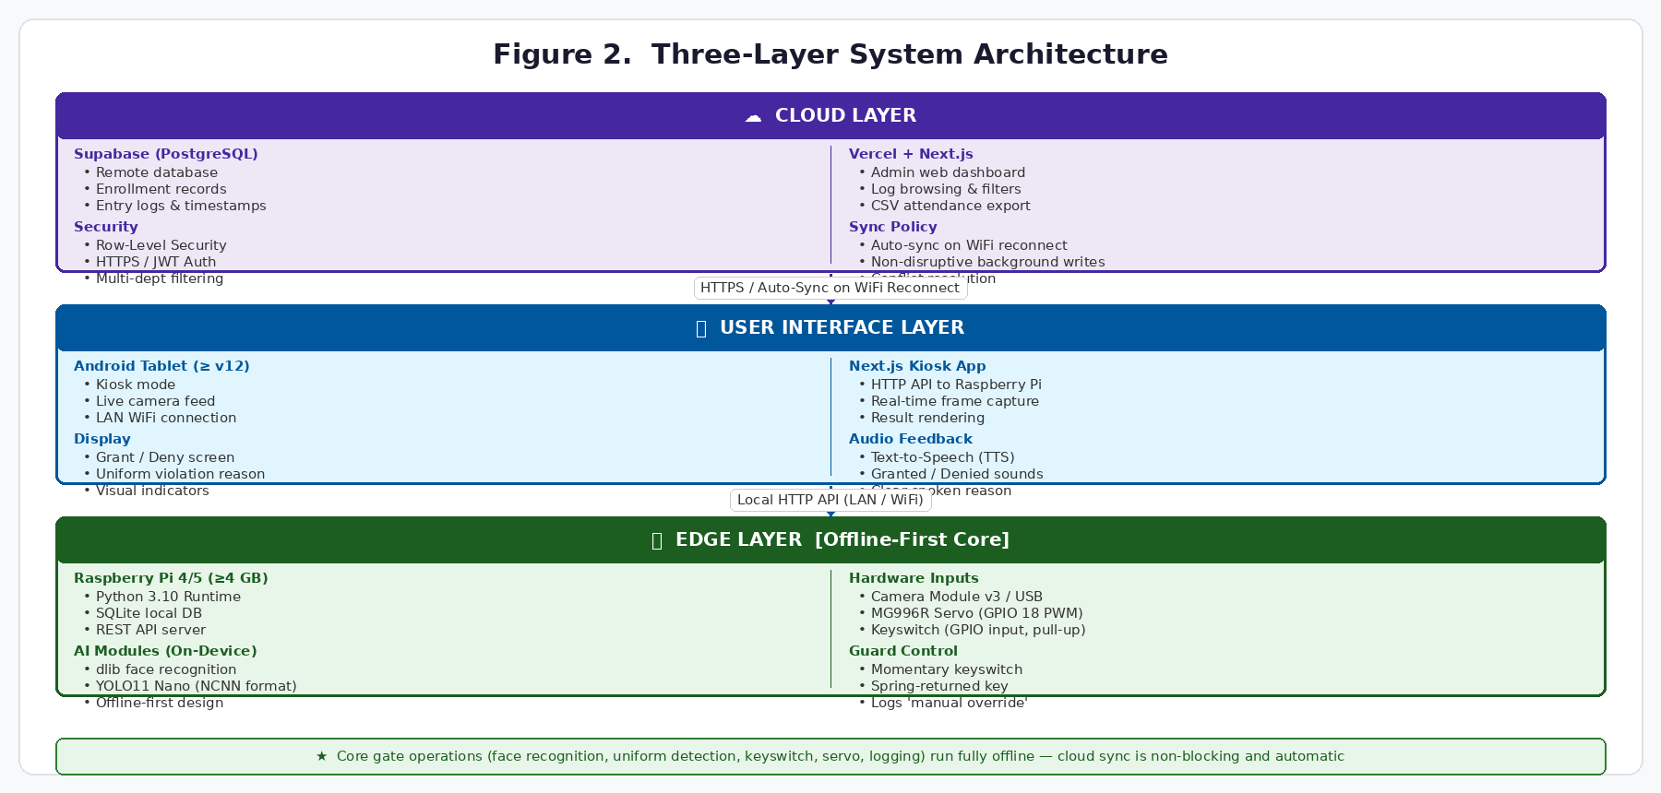 It runs the Python-based face recognition pipeline using dlib, the YOLO11 Nano uniform top detection model in NCNN format, the GPIO-connected keyswitch monitoring routine, and the MG996R servo motor gate control. All data processed at the edge is stored locally in a SQLite database, ensuring that the gate continues to function in the absence of network connectivity.
User Interface Layer. Implemented on an Android tablet mounted at the gate kiosk, the User Interface Layer runs a Next.js web application in kiosk mode. It displays a live camera feed to the student, communicates capture requests and access decisions with the Raspberry Pi via a local HTTP API, presents gate open or denial outcomes with specific reason text (unknown face or non-compliant uniform), and provides text-to-speech audio feedback.
Cloud Layer. Hosted on Supabase and deployed via Vercel, the Cloud Layer stores synchronized copies of student enrollment records and entry logs in a PostgreSQL database. The administrator web dashboard enables student enrollment management, entry log browsing with date filtering, and CSV export of entry timestamps for administrative monitoring. All cloud communication uses HTTPS and Supabase's Row-Level Security policies.
3.3 Software Development Life Cycle (SDLC)
This study adopts the Prototyping Model as its SDLC approach. The Prototyping model is specifically chosen because the project involves building a working prototype for a novel application where iterative feedback from testing and real-world use is essential to refining the system. Figure 3 illustrates the seven iterative phases of the Prototyping Model as applied in this study.
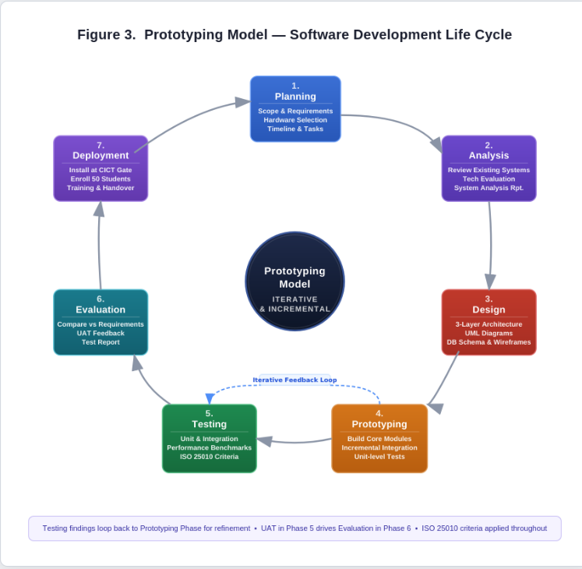

Figure 3. Prototyping Model — Software Development Life Cycle (SDLC)
The SDLC consists of seven iterative phases, each described in future tense as the project is still in the proposal stage:
Planning Phase. The researchers will define project scope, functional requirements, hardware components (Raspberry Pi, camera, servo, keyswitch, Android tablet), and software technologies (Python 3.10, dlib, YOLO11, Next.js, Supabase). A detailed timeline and work breakdown structure will be created.
Analysis Phase. The researchers will analyze existing campus gate systems and their limitations, evaluate the dlib and YOLO11 Nano technologies against accuracy and performance requirements, and produce a System Analysis Report documenting design decisions.
Design Phase. The researchers will create the three-layer system architecture, design the SQLite database schema, produce interface wireframes for the tablet kiosk and admin dashboard, define REST API endpoints, and generate the following UML diagrams to document system behavior:

Use Case Diagram — illustrating student entry, automatic gate decision, keyswitch override, and admin dashboard functions:

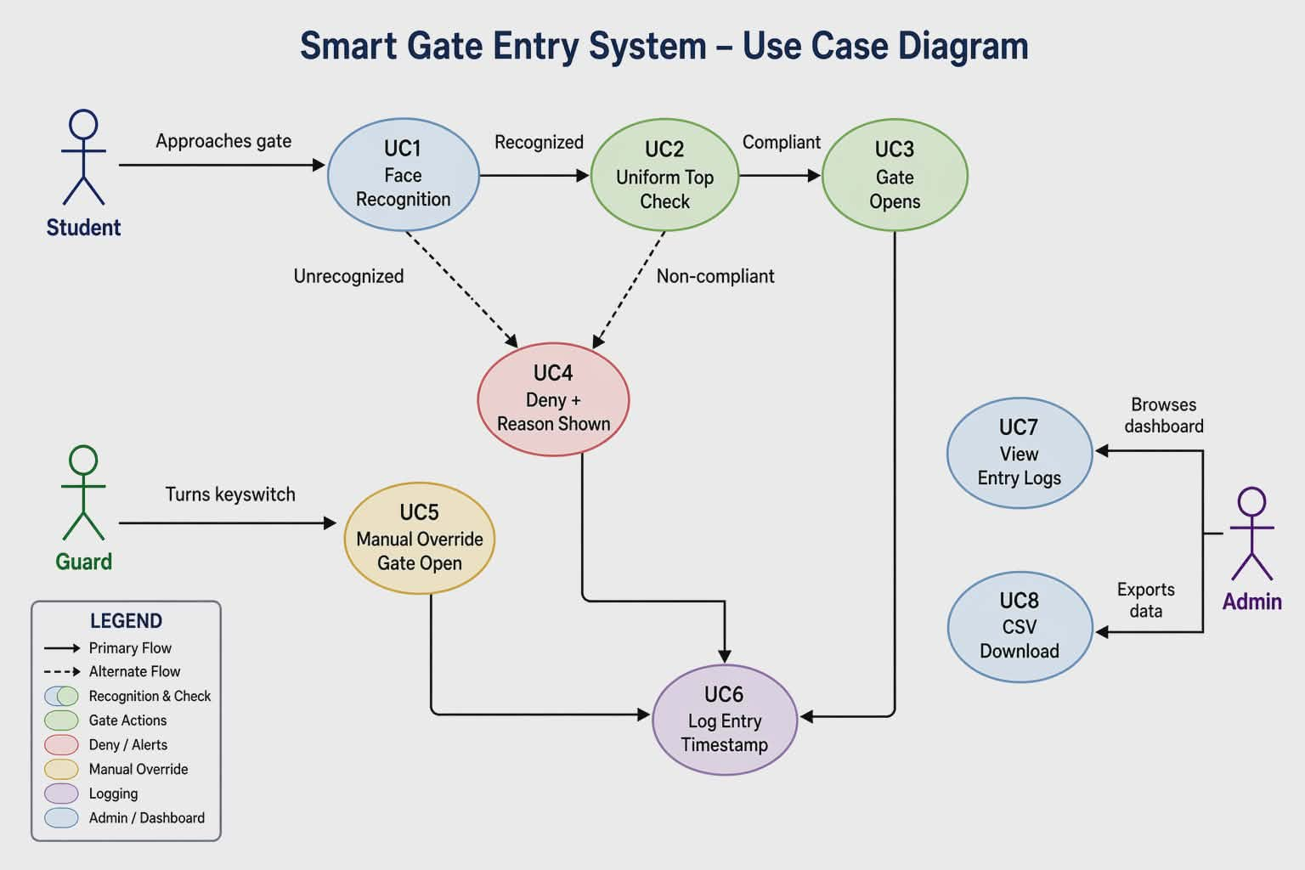

Activity Diagram — describing the sequential gate logic from student arrival to gate decision:
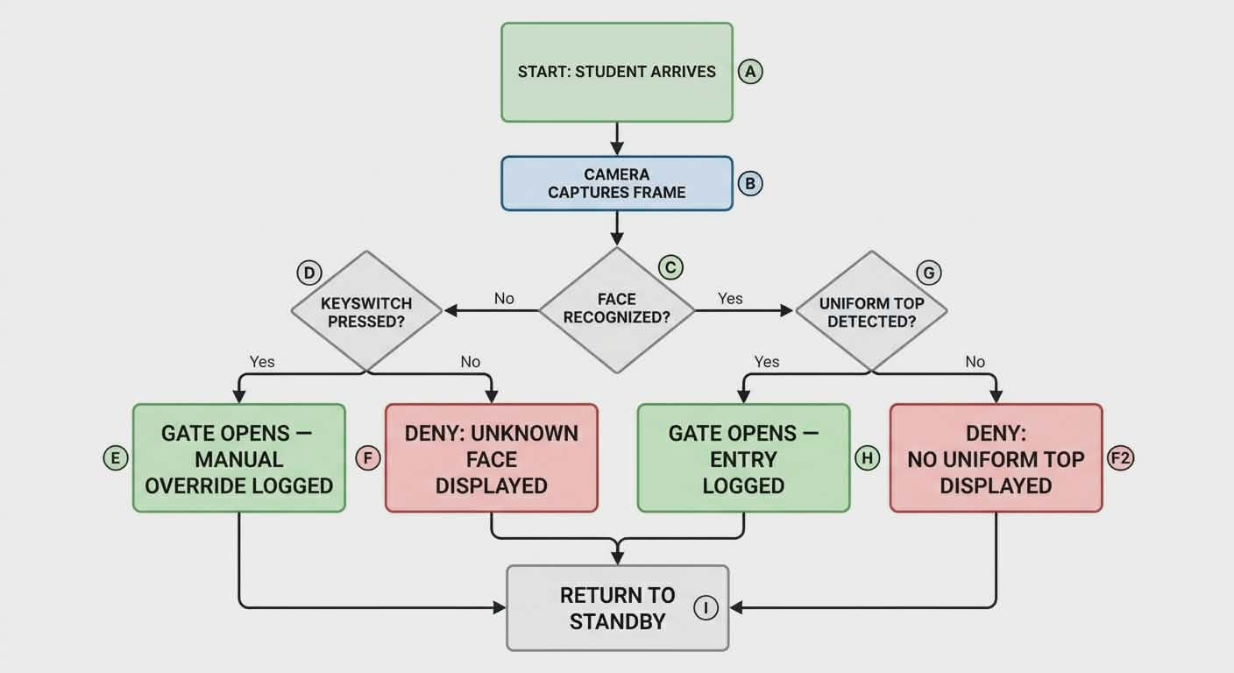
Sequence Diagram — showing the message flow between the tablet, Raspberry Pi, and cloud:

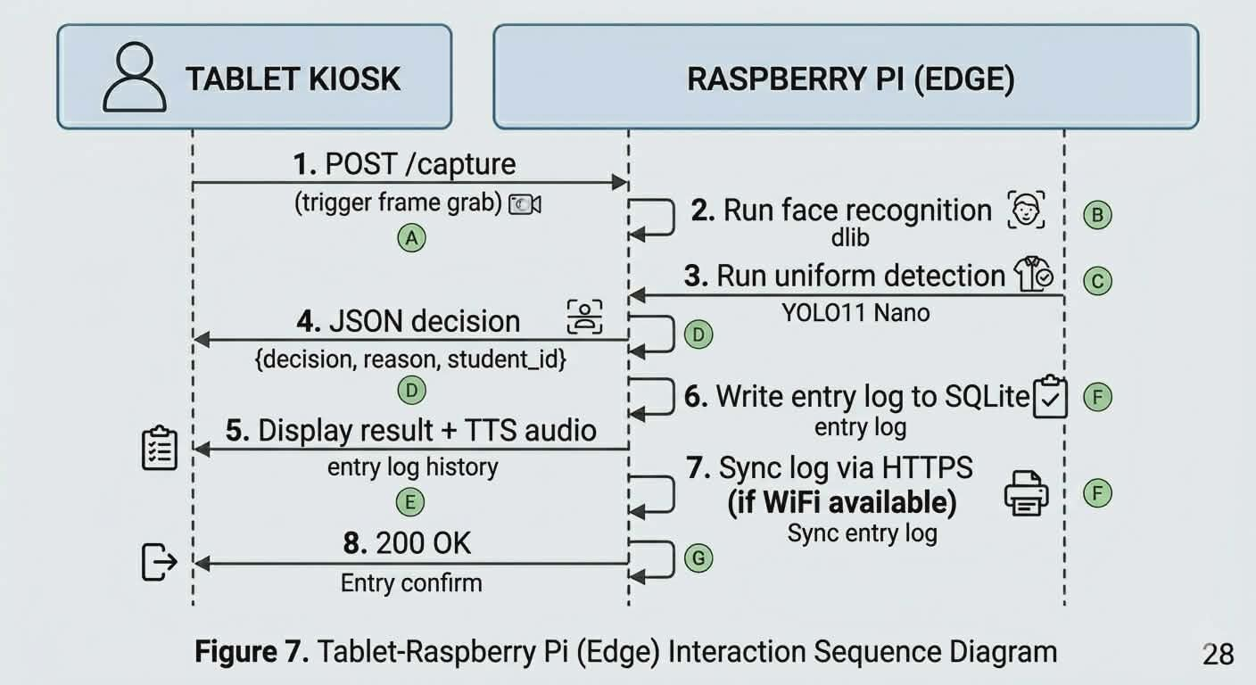
Deployment Diagram — showing physical hardware and software placement:
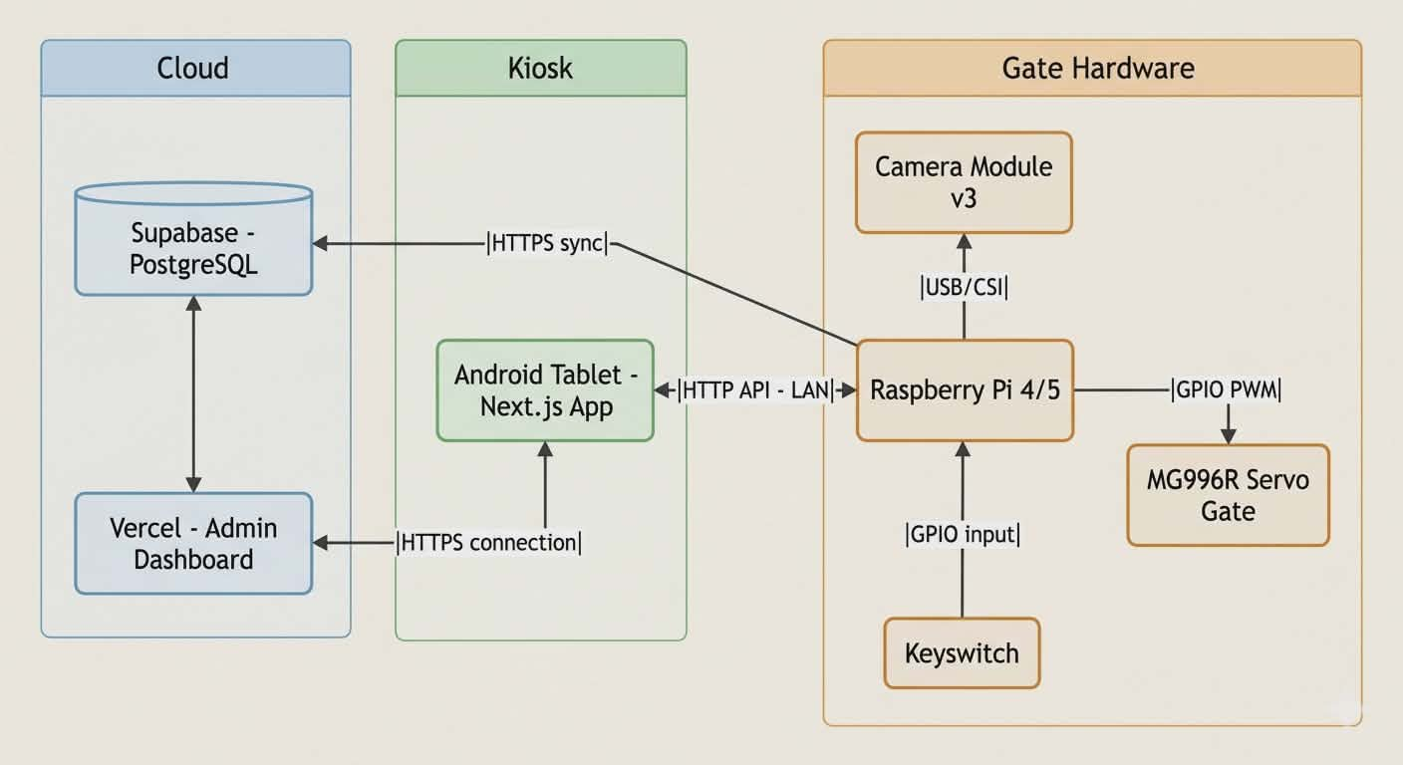

Entity-Relationship Diagram (ERD) — showing the SQLite/PostgreSQL database
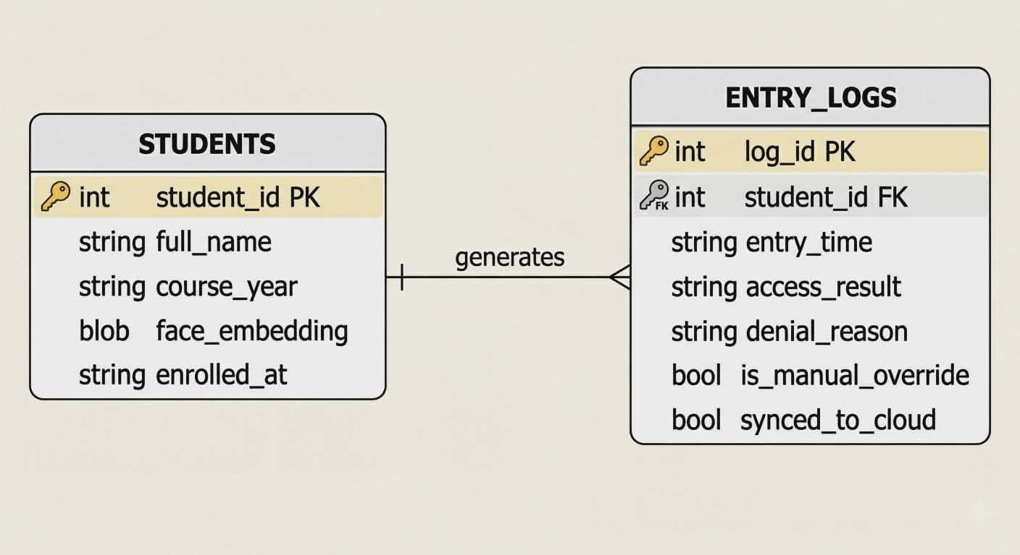
Prototyping Phase. The researchers will build the initial working prototype incrementally, developing and testing each module before integration: the dlib face enrollment and verification pipeline, the YOLO11 Nano model trained on CICT uniform images and exported to NCNN, the keyswitch GPIO monitoring and override logic, the MG996R servo gate control, the Next.js kiosk application, and the Supabase admin dashboard.
Testing Phase. The researchers will execute unit, integration, performance, robustness, and UAT tests as described in Section 3.6. Findings will feed back into the Prototyping Phase for refinement.
Evaluation Phase. The refined prototype will be evaluated against ISO 25010 criteria. A Test Report and UAT Summary will be compiled.
Deployment Phase. The researchers will install the system at the CICT gate, enroll the initial student cohort, train the security guard on keyswitch operation and exception procedures, and produce a User Manual and Maintenance Guide.
3.4 Hardware Components
The prototype system requires five hardware components. Figure 4 illustrates the complete wiring and connection layout.
Raspberry Pi 4 Model B or Raspberry Pi 5 (≥ 4 GB RAM). Serves as the edge computing device responsible for all AI inference, database management, and gate control. Runs Python 3.10, dlib, YOLO11 Nano, SQLite, and the REST API server. Powered by a 5V 3A USB-C adapter.
Camera Module v3 or USB Webcam. Used to capture face images and full-body frames for uniform detection. Connected to the Raspberry Pi via CSI ribbon cable or USB. Both face recognition and uniform detection draw from this single camera.
MG996R Metal-Gear Servo Motor. Connected to GPIO pin 18 via PWM at 50 Hz. Simulates the physical opening and closing of the gate barrier in the prototype. Opens to 90° when access is granted and returns to 0° after a configured dwell time.
Momentary Keyswitch (Spring-Returned, Lockable). Connected to a GPIO input pin configured with an internal pull-up resistor. The security guard holds the physical key, which is the only way to activate the switch. When the guard turns and holds the key for one to two seconds, the system detects the GPIO state change, opens the gate once, and records the event as a 'manual override' in the SQLite log. When the key is released, the switch springs back to the off position automatically.
Android Tablet (≥ Android 12). Hosts the Next.js kiosk application, providing the display seen by the student (live camera preview, access result, denial reason) and the text-to-speech audio feedback. Communicates with the Raspberry Pi over the local Wi-Fi network via HTTP API.

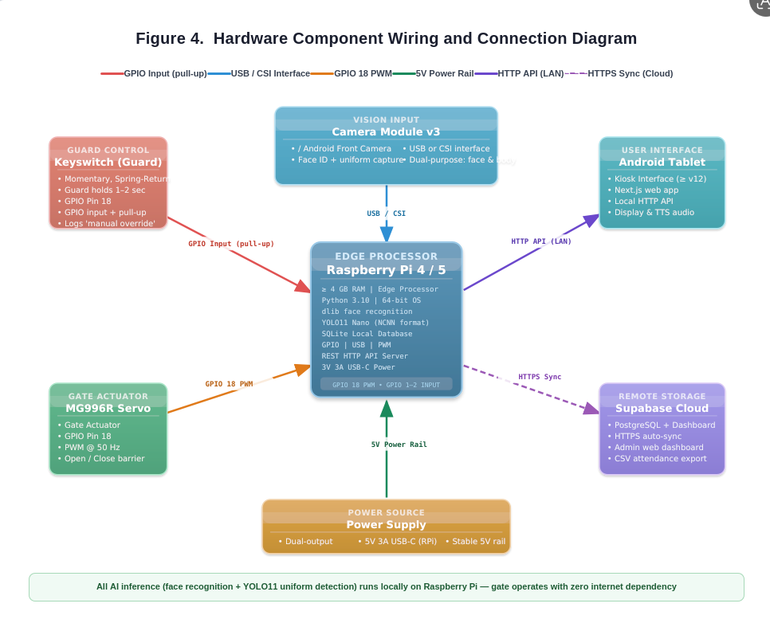
Figure 4. Hardware Component Wiring and Connection Diagram of the Smart Gate Prototype

3.5 Software Development Phases
Software development will proceed in eight two-week sprints aligned with the Prototyping SDLC. During Weeks 1–2, the development environment will be prepared: Raspberry Pi OS (64-bit) will be installed, a Python 3.10 virtual environment will be configured, and required libraries face_recognition, ultralytics for YOLO11, opencv-python will be installed and verified. The keyswitch GPIO input will be wired and tested for signal reliability.
During Weeks 3–4, the face recognition modules will be built. The face enrollment pipeline will capture multiple images per student, extract dlib embeddings, and store them in SQLite. The real-time face verification pipeline will be implemented and tested with initial accuracy documentation.
During Weeks 5–6, the AI dress code detection module will be developed. A labeled training dataset of CICT uniform top images will be collected and annotated. The YOLO11 Nano model will be trained on this dataset and exported to NCNN format for optimized Raspberry Pi inference.
During Weeks 7–8, the keyswitch override logic and servo gate control will be integrated. The GPIO interrupt handler for the keyswitch will be implemented, ensuring debouncing and secure single-trigger behavior. The MG996R PWM sequences for gate open and close will be programmed and tested end-to-end with the keyswitch trigger.
During Weeks 9–10, the Next.js tablet kiosk application will be built, including the camera capture interface, HTTP API client, access result display with denial reason text, and TTS audio feedback.
During Weeks 11–12, the Supabase cloud backend will be configured. PostgreSQL tables for students and entry logs will be set up with Row-Level Security, and the administrator web dashboard will be built with enrollment management, log browsing, and CSV export.
During Weeks 13–14, all modules will be connected end-to-end and full integration testing will be conducted. YOLO11 confidence thresholds will be tuned. The keyswitch debounce and timing parameters will be finalized.
During Weeks 15–16, User Acceptance Testing will be conducted with CICT student volunteers, ISO 25010 evaluation data will be collected, all documentation and UML diagrams will be finalized, and the defense presentation will be prepared.
3.6 Testing Plan
The system will be evaluated through five testing levels grounded in ISO 25010 quality characteristics:
Unit Testing. Each module will be tested in isolation: face recognition accuracy on a held-out set of 10 enrolled student images under normal and low-light conditions; YOLO11 Nano detection precision and recall on a labeled validation set of 50 uniform and non-uniform images; keyswitch GPIO debouncing and trigger reliability over 30 consecutive activations; servo motor gate open and close cycle consistency.
Integration Testing. End-to-end access scenarios will be executed covering four cases: a fully compliant enrolled student (should be admitted and logged), an enrolled student not wearing the uniform top (should be denied with reason 'no uniform top detected'), an unrecognized person (should be denied with reason 'face not recognized'), and a guard-activated keyswitch override (should open once and log 'manual override').
Performance Testing (ISO 25010 — Performance Efficiency). Face recognition processing time per student will be measured against the 1.5-second target. Full gate cycle time from camera capture to servo actuation will be measured against the 3.5-second target. Tests will be conducted on both Raspberry Pi 4 and Raspberry Pi 5 for comparison.
Robustness Testing (ISO 25010 — Reliability). System behavior will be evaluated under direct sunlight, artificial fluorescent lighting, and dim corridor conditions, as well as under face occlusion from caps and face coverings, and at varying camera entry angles.
User Acceptance Testing (ISO 25010 — Usability). A group of CICT student volunteers will simulate a realistic school-day entry scenario. Structured feedback will be collected via questionnaire covering ease of use, perceived speed, display clarity, audio feedback, and overall satisfaction. The security guard will be asked to evaluate the keyswitch mechanism for ease of operation.
3.7 Scalability Considerations
The system is architected to scale beyond the initial single-department prototype with minimal structural changes. The SQLite schema includes a department code field per student record, allowing different uniform detection models per department. The YOLO11 Nano model can be retrained on additional department uniform images by re-running the training pipeline with no architectural changes. The Supabase dashboard is built with multi-department filtering from the outset. Physical expansion to additional campus gates requires only deploying additional Raspberry Pi units, each registering as a new gate node in Supabase. Additional keyswitch units can be wired in parallel on the same GPIO pin with no software changes.
3.8 Development Timeline

Week | Milestone and Deliverables
1–2 | Raspberry Pi OS and Python 3.10 setup; dlib and YOLO11 library installation; initial face recognition smoke test.
3–4 | Face recognition enrollment module complete; initial accuracy tests documented against held-out student images.
5–6 | CICT uniform dataset collected and labeled; YOLO11 Nano model trained and exported to NCNN format; detection validated.
7–8 | Keyswitch hardware wired to GPIO; override logic and manual-override logging implemented; MG996R servo gate control tested.
9–10 | Next.js kiosk UI complete with camera capture, result display, TTS audio feedback, and keyswitch status indicator.
11–12 | Supabase backend configured; admin dashboard with student enrollment, log browsing, and CSV export functional; offline sync implemented.
13–14 | Full system integration; end-to-end testing; performance tuning; ISO 25010 evaluation criteria applied.
15–16 | UAT with CICT student volunteers; all documentation and UML diagrams finalized; defense presentation prepared.

APPENDICES
Appendix A: Gantt Chart of Development Timeline
[Placeholder — Gantt chart will be inserted here. The chart will display all 16 weeks of development across Weeks 1–16, showing each milestone from Section 3.8 as horizontal bars, with color coding for completed vs. planned phases. The Gantt chart will be generated using project management software and attached as a full-page landscape figure prior to the capstone defense.]

References
Alharbi, S., Alghofaili, Y., & Alotaibi, A. (2022). Facial recognition-based access control system for university campuses. Journal of King Saud University – Computer and Information Sciences, 34(8), 5872–5882. https://doi.org/10.1016/j.jksuci.2021.09.015
Ashton, K. (2009). That 'internet of things' thing. RFID Journal, 22(7), 97–114. https://www.rfidjournal.com/that-internet-of-things-thing
Bradski, G., & Kaehler, A. (2008). Learning OpenCV: Computer vision with the OpenCV library. O'Reilly Media.
Chowdhury, M. R., Rahman, M. A., & Islam, M. S. (2021). Face recognition-based student attendance system with preprocessing under variable lighting. IEEE Access, 9, 78431–78443. https://ieeexplore.ieee.org/document/9429933
Dela Cruz, R., & Santos, M. (2022). Challenges in campus security management in Philippine state universities. Philippine Journal of Education and Technology, 11(2), 45–59.
DeMitchell, T. A., & Fossey, R. (2015). The lawful school: Legal issues facing educational administrators. Rowman & Littlefield.
Fagbola, T. M., Thakur, S., & Adigun, M. O. (2019). Comparative analysis of unimodal and multimodal biometric systems for student identification. International Journal of Electrical and Computer Engineering, 9(5), 4115–4124. https://doi.org/10.11591/ijece.v9i5.pp4115-4124
Handayani, D., Suyanto, M., & Nugroho, A. (2022). Raspberry Pi-based facial recognition system for automated student attendance monitoring in vocational schools. TELKOMNIKA Telecommunication, Computing, Electronics and Control, 20(3), 544–552. https://doi.org/10.12928/telkomnika.v20i3.22665
Hipp, D. R. (2020). SQLite: A self-contained, serverless, zero-configuration, transactional SQL database engine. SQLite Consortium. https://www.sqlite.org/about.html
Hoang, L. H., & Anh, L. N. H. (2024). Verification of student uniform by convolutional neural network through images. International Journal of Novel Research and Development, 9(5), 656–665. https://www.ijnrd.org/papers/IJNRD2405171.pdf
ISO/IEC. (2011). ISO/IEC 25010: Systems and software engineering — Systems and software quality requirements and evaluation (SQuaRE) — System and software quality models. International Organization for Standardization.
Jain, A. K., Ross, A., & Pankanti, S. (2006). Biometrics: A tool for information security. IEEE Transactions on Information Forensics and Security, 1(2), 125–143. https://doi.org/10.1109/TIFS.2006.873653
King, D. (2017). High quality face recognition with deep metric learning. dlib Blog. https://blog.dlib.net/2017/02/high-quality-face-recognition-with-deep.html
Kumari, A., Tanwar, S., Tyagi, S., & Kumar, N. (2022). Verification and validation techniques for streaming big data analytics in Internet of Things environments. IET Networks, 11(3), 95–107. https://doi.org/10.1049/ntw2.12046
Kuphaldt, T. R. (2006). Lessons in electric circuits: Volume IV — Digital. Ibiblio. https://www.ibiblio.org/kuphaldt/electricCircuits/Digital/
Maltoni, D., Maio, D., Jain, A. K., & Prabhakar, S. (2009). Handbook of fingerprint recognition (2nd ed.). Springer.
Manalansan, B. (2023). Security gaps in Philippine academic institutions: A review of campus access control practices. Journal of Philippine Higher Education Administration, 5(1), 12–27.
Masombuka, T. M., Nyandeni, N., & Lall, M. (2023). Automated uniform recognition to enhance video surveillance. MATEC Web of Conferences, 388, 11001. https://doi.org/10.1051/matecconf/202338811001
Mukherjee, S., Bhatt, C., & Dhavale, S. (2021). A machine learning pipeline for school uniform identification. In Proceedings of the ACM Conference on AI for Good. https://doi.org/10.1145/3462203.3475924
Oloniyo, O., Samuel, F. D., & Fredrick, A. (2025). Design of a multimodal attendance system using RFID, face recognition, fingerprint biometric, and GSM notification. International Journal of Innovative Science and Research Technology, 10(8), 1266–1275. https://www.ijisrt.com/assets/upload/files/IJISRT25AUG720.pdf
Rahman, M. M., Islam, M. S., & Hossain, M. A. (2023). Smart attendance and access control system using RFID and fingerprint biometrics. International Journal of Advanced Computer Science and Applications, 14(2), 345–352. https://doi.org/10.14569/IJACSA.2023.0140237
Redmon, J., Divvala, S., Girshick, R., & Farhadi, A. (2016). You only look once: Unified, real-time object detection. In Proceedings of the IEEE Conference on Computer Vision and Pattern Recognition (CVPR), 779–788. https://doi.org/10.1109/CVPR.2016.91
Ren, S., He, K., Girshick, R., & Sun, J. (2015). Faster R-CNN: Towards real-time object detection with region proposal networks. Advances in Neural Information Processing Systems, 28, 91–99.
Richey, R. C., & Klein, J. D. (2007). Design and development research: Methods, strategies, and issues. Lawrence Erlbaum Associates.
Shi, W., Cao, J., Zhang, Q., Li, Y., & Xu, L. (2016). Edge computing: Vision and challenges. IEEE Internet of Things Journal, 3(5), 637–646. https://doi.org/10.1109/JIOT.2016.2579198
Sikos, L. F. (2019). AI in cybersecurity. Springer.
Suh, J., & Lee, J. (2022). Edge computing-based smart campus system for real-time monitoring and access control. IEEE Access, 10, 12345–12356. https://ieeexplore.ieee.org/document/9756695
Supabase Inc. (2023). Supabase documentation: Open-source Firebase alternative. https://supabase.com/docs
Ultralytics. (2024). YOLO11: The latest Ultralytics YOLO model. Ultralytics Documentation. https://docs.ultralytics.com/models/yolo11/
Vacca, J. R. (Ed.). (2013). Computer and information security handbook (2nd ed.). Morgan Kaufmann.
W3C. (2013). Offline web applications. World Wide Web Consortium. https://www.w3.org/TR/offline-webapps/
Zhao, W., Chellappa, R., Phillips, P. J., & Rosenfeld, A. (2003). Face recognition: A literature survey. ACM Computing Surveys, 35(4), 399–458. https://doi.org/10.1145/954339.954342

